PREDICTING HOUSE PRICES USING

MACHINE LEARNING

Problem definition:

The objective is to create a machine learning model that, using a variety of input features can precisely forecast the selling prices of residential properties. Regression analysis is the field in which this issue belongs. The goal is to develop a predictive model that can aid real estate professionals, owners, or prospective buyers in calculating the market worth of a home while taking into account details like its size, location, number of bedrooms, bathrooms, and other pertinent characteristics.



The housing market is an important sector that plays a vital role in people’s life in different ways. For many of us buying a house is a very important thing in our lifetime. So it is essential to make it easy for the people to predict the prices of the houses that they are going to buy and it is also needed for the sellers too.

By this method we can make predicting the house prices easier for the buyers and the sellers so that they can make their decisions upon buying or selling the houses more easier and convenient.

DESIGN AND THINKING:

* Objective :

The objective of this project is to develop a machine learning model to predict or forecast the selling prices of the houses and residential properties. The model should able to assist the real estate professionals, houseowners and the buyers to estimate the house’s market value.

* Data Source :

The Data source for the house price prediction using machine learning should be Accurate,Complete,Accessible. Source link: <https://www.kaggle.com/datasets/vedavyasv/usa-housing>

* Data preprocessing:

In this phase the data is collected form various resources for the analysis. The data should be preprocessed after it is collected. The preprocessing of data is to make the data more precise and clean. It ensure that it has no missing values or incomplete data in it. The preprocessing of data is a important step in the analysis.

* Feature selection:

In machine learning and data analysis, feature selection is a crucial stage where you select the most pertinent and instructive features (variables) from your dataset to use for model construction. The performance of a model, its ability to be interpreted, and overfitting can all be improved with careful feature selection.

* Model selection:

Various machine learning algorithms are explored, including linear regression, decision trees, random forests, support vector machines, and neural networks. Hyperparameter tuning is performed to optimize model performance.

* Model training:

The model training is a fundamental step in the machine learning where the model learns to make predictions on a specific task based on the data. The training is done with the preprocessed data, it is to avoid overfitting or underfitting of the model.

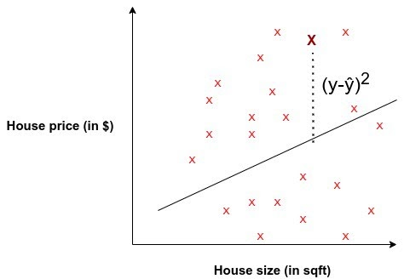

* Evaluation:

The model is evaluated based on their performance on the test data set. The effectiveness of the model is based on the evaluation metrices such as the errors that the model makes. The cross validation techniques are applied to ensure the robustness of the model.